**Analysis and Design of Linear Systems**

(IN26007)



Lab Experiment 02

SUBMITTED BY

**MAHMOOD HASSAN (117035990004)**

*State space modeling of an inverted pendulum system*

2018

Submitted By;

Mahmood ul Hassan

(117035990004)

Objectives1) Learn how to build the state space model of a real system using MATLAB.

2) How to analyze and linearize a real system.

3) Learn how to find different forms of a system using similarity transformation.

Experiment steps

The given method of linearization of an inverted pendulum system shown in fig 1 is described below.

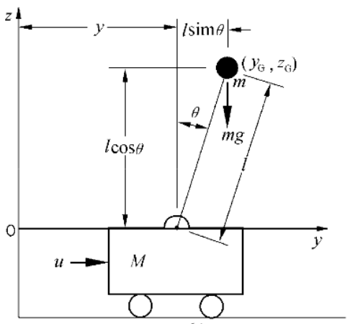

Figure 1Inverted Pendulum

Assume that coordinate of ball is 

Then ,

.

Therefore



⇒

⇒

Let the system is under condition, so the system can be linearized at,,, which means the following conditions can be applied .



So the linear system can be described as,





The final linear model of the system is as follows.





According to the given linear model, assume that:

**State variables:** movement, speed, angle, angle rate

**Input:** force u

**Output:** movement 

Assume that: ,

Question 01

Build a state space model of the system and determine the parameters.

# Solution of Question 01

# Calculations

Let

$$x_{1}=y \\ x_{2}=\dot{y}={\dot{x}}_{1} \\ x_{3}=θ \\ x_{4}=\dot{θ}={\dot{x}}_{3}$$

In other way

$$\vec{x} =\left[\begin{aligned}x_{1} \\ x_{2} \\ x_{3} \\ x_{4}\end{aligned}\right]= \left[\begin{aligned}y \\ \dot{y} \\ θ \\ \dot{θ}\end{aligned}\right]$$

After putting these supposed state in linear model of system we get state space model of system

$$\left[\begin{aligned}x_{1} \\ x_{2} \\ x_{3} \\ x_{4}\end{aligned}\right]= \left[\begin{matrix}0 & 1 & 0 & 0 \\ 0 & 0 & -\frac{mg}{M} & 0 \\ 0 & 0 & 0 & 1 \\ 0 & 0 & \frac{\left(m+M\right)g}{Ml} & 0\end{matrix}\right]\left[\begin{aligned}x_{1} \\ x_{2} \\ x_{3} \\ x_{4}\end{aligned}\right]+ \left[\begin{aligned}0 \\ \frac{1}{M} \\ 0 \\ -\frac{1}{Ml}\end{aligned}\right]u$$

$$y= \left[1 0 0 0\right] \left[\begin{aligned}x_{1} \\ x_{2} \\ x_{3} \\ x_{4}\end{aligned}\right]$$

After determining parameters

$$\left[\begin{aligned}x_{1} \\ x_{2} \\ x_{3} \\ x_{4}\end{aligned}\right]= \left[\begin{matrix}0 & 1 & 0 & 0 \\ 0 & 0 & -0.98 & 0 \\ 0 & 0 & 0 & 1 \\ 0 & 0 & 10.78 & 0\end{matrix}\right]\left[\begin{aligned}x_{1} \\ x_{2} \\ x_{3} \\ x_{4}\end{aligned}\right]+ \left[\begin{aligned}0 \\ 1 \\ 0 \\ -1\end{aligned}\right]u$$

$$y= \left[1 0 0 0\right] \left[\begin{aligned}x_{1} \\ x_{2} \\ x_{3} \\ x_{4}\end{aligned}\right]$$

# Matlab Steps

In Matlab for finding the state space model first we define the matrix A, B, C, D and parameters m, M, l, g in matlab then we find state space model using matlab command **“sys = ss(A, B, C, D)”**.

# Matlab Result

Matlab Result of state space model is given below.

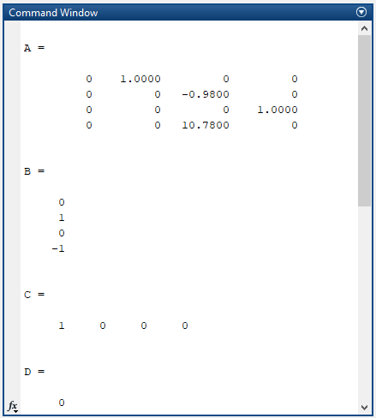

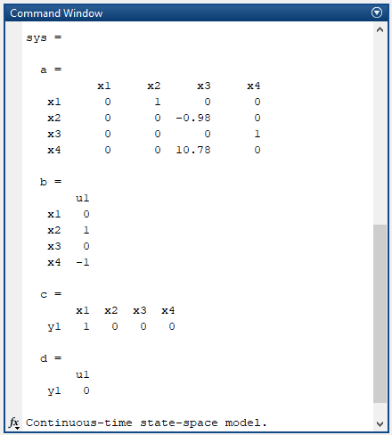

# Matlab Code

%Question No 1

%Build a state space model of the system and determine the parameters.

close all;

clear all;

clc;

%Define the Parameters m, M, l, g.

m=0.1;

M=1;

l=1;

g=9.8;

%Define the matrix A, B, C, D

A=[0 1 0 0; 0 0 (-m*g)/M 0; 0 0 0 1; 0 0 (m+M)*g/(M*l) 0]

B=[0 1/M 0 -1/M ]'

C=[1 0 0 0]

D=0

%Find state space model using matlab command “sys = ss(A, B, C, D)”.

sys = ss(A,B,C,D)

# Question 02

Find poles of the system by using the similarity transformation.

# Solution of Question 02

Basic Theory

# Some introduction of similarity transformation is given below

$$\dot{x}=Ax+Bu \\ y=Cx+Du$$

System can be transferred by similarity transformation if there is nxn nonsingular matrix P $$\overline{x}=Px \\ \overline{A}=PAP^{-1} \\ \overline{B}=PB \\ \overline{C}=CP^{-1} \\ \overline{D}=D$$

After transformation system is algebraically equivalent to below state equation

$$\dot{\overline{x}}=\overline{A}x+\overline{B}u \\ y=\overline{C}x+\overline{D}u$$

# Matlab Steps

1. From the given state space model we define the matrix A, B, C, D and parameters m, M, l, g in matlab. As Eigen values computed by using state space matrix are same as poles of system. We find Eigenvalues and matrix of Eigenvector using matlab command **“[EigenVector, EigenVal_Digonal]=eig(A)”.**
2. We plot the poles first by using command **“pzmap(sys)”.**

# Matlab Result

Matlab Result of Eigen Value and Eigen Vector is given below. As Eigen values computed by using state space matrix are same as poles of system. The poles of the system are (0,0,-3.3166,3.3166).

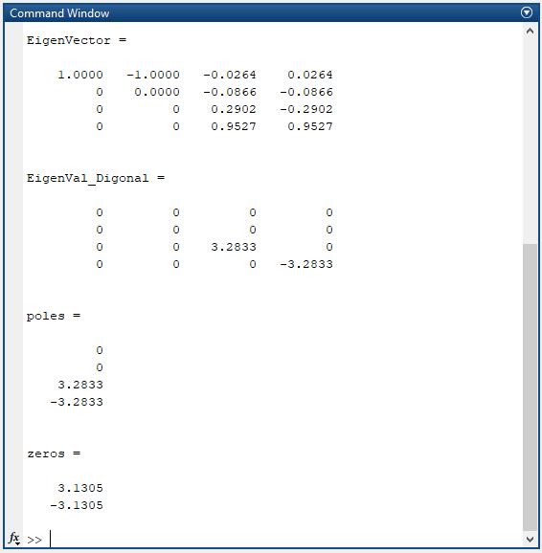

Matlab plot of Poles and zeroes is given below.

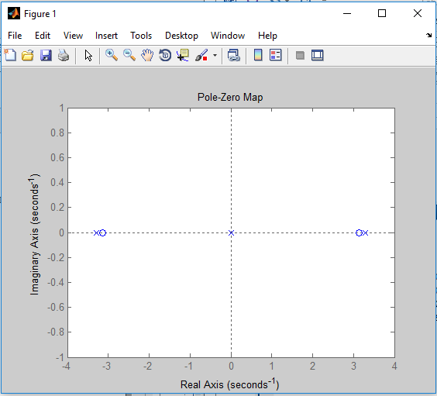

# Matlab Code

%Question 02

%Find poles of the system by using the similarity transformation.

close all;

clear all;

clc;

% Define the Parameters m, M, l, g.

m=0.1;

M=1;

l=1;

g=9.8;

% Define the matrix A, B, C, D

A=[0 1 0 0; 0 0 (-m*g)/M 0; 0 0 0 1; 0 0 (m+M)*g/(M*l) 0]

B=[0 1/M 0 -1/M ]'

C=[1 0 0 0]

D=0;

%As Eigen values are same as poles of system.

%We find Eigenvalues

[EigenVector,EigenVal_Digonal]=eig(A)

sys = ss(A,B,C,D);

[poles,zeros]= pzmap(sys)

pzmap(sys)

# Question 03

# Find **controllable canonical form** of the system by similarity transformation and calculate the transformation matrix.

# Solution of Question 03

Basic Theory

If system (A, B) is controllable it can be transferred into canonical controllable as follows





$$\det\left[λI-A\right]=λ^{n}+a_{n-1}λ^{n-1}+…+a_{1}λ+a_{0}$$

we can find the controllable canonical form using

$\overline{x}=Px$ $\overline{A}=PAP^{-1}$ $\overline{B}=PB$ $\overline{C}=CP^{-1}$ $\overline{D}=D$

# Matlab Steps

1. From the given state space model we define the matrix A, B, C, D and parameters m, M, l, g in matlab.
2. We find the controllability matrix (Kalman matrix) using matlab command **Q= ctrb(A,B)** and check its rank to confirm whether it’s controllable or not using matlab command **rank(Q).** We found system is controllable having rank 4.
3. Then we find the characteristic polynomial of system to find matrix W.
   1. The characteristic polynomial is $λ^{4}-10.78λ^{2}$.
   2. This will give coefficients which are $a_{1}=0, a_{2}=-10.78, a_{3}=0$
4. After that we find the inverse of the transformation matrix P by multiplying controllable matrix Q with the matrix of coefficients W.
5. Then we find the Abar, Bbar, Cbar, Dbar using

$\overline{A}=PAP^{-1}$ $\overline{B}=PB$ $\overline{C}=CP^{-1}$ $\overline{D}=D$

# Matlab Result

Matlab Result of the controllability matrix (Kalman matrix) and its rank is given below.

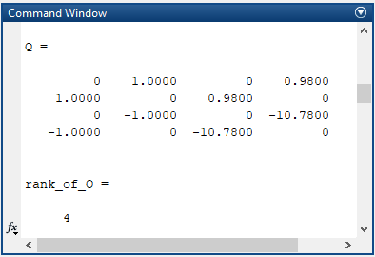

Matlab Result of the inverse of the transformation matrix P and matrix P is given below

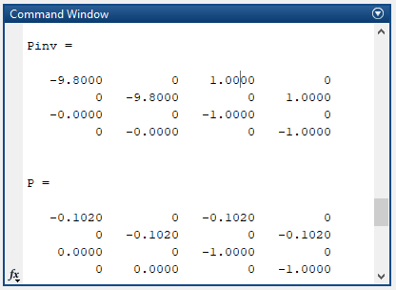

Matlab Result of controllable canonical form is given below

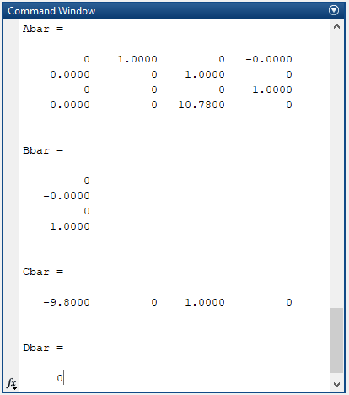

Matlab Result of controllable canonical form is given below

$$\left[\begin{aligned}x_{1} \\ x_{2} \\ x_{3} \\ x_{4}\end{aligned}\right]= \left[\begin{matrix}0 & 1 & 0 & 0 \\ 0 & 0 & 1 & 0 \\ 0 & 0 & 0 & 1 \\ 0 & 0 & 10.78 & 0\end{matrix}\right]\left[\begin{aligned}x_{1} \\ x_{2} \\ x_{3} \\ x_{4}\end{aligned}\right]+ \left[\begin{aligned}0 \\ 0 \\ 0 \\ 1\end{aligned}\right]u$$

$$y= \left[-9.8 0 1 0\right] \left[\begin{aligned}x_{1} \\ x_{2} \\ x_{3} \\ x_{4}\end{aligned}\right]$$

# Matlab Code

%Question No 3

%Find controllable canonical form of the system by similarity transformation

%and calculate the transformation matrix.

close all;

clear all;

clc;

%Define the Parameters m, M, l, g.

syms s;

m=0.1;

M=1;

l=1;

g=9.8;

%Define the matrix A, B, C, D, I

A=[0 1 0 0; 0 0 (-m*g)/M 0; 0 0 0 1; 0 0 (m+M)*g/(M*l) 0]

B=[0 1/M 0 -1/M ]'

C=[1 0 0 0]

D=0;

I=eye(4)

%Find the controllability matrix Q and check its rank

Q= ctrb(A,B)

rank_of_Q = rank(Q)

Rank_Diff=length(A)-rank(Q)

%find the characteristic Equation of system and find matrix W

poly=det(s*I-A)

coeff = sym2poly(poly)

a1=coeff(2)

a2=coeff(3)

a3=coeff(4)

W=[a1 a2 a3 1; a2 a3 1 0; a3 1 0 0; 1 0 0 0]

%find transformation matrix P

Pinv=Q*W

P=inv(Pinv)

%find the controllable canonical form

Abar=P*A*Pinv

Bbar=P*B

Cbar=C*Pinv

Dbar=D

Question 04

Find **observable canonical form** of the system by similarity transformation and calculate the transformation matrix.

# Solution of Question 04

Basic Theory

If system (C, A) is observable it can be transferred into canonical observable form as follows





$$\det\left[λI-A\right]=λ^{n}+a_{n-1}λ^{n-1}+…+a_{1}λ+a_{0}$$

we can find the controllable canonical form using

$\overline{x}=Px$ $\overline{A}=PAP^{-1}$ $\overline{B}=PB$ $\overline{C}=CP^{-1}$ $\overline{D}=D$

# Matlab Steps

1. From the given state space model we define the matrix A, B, C, D and parameters m, M, l, g in matlab.

We find the observability matrix (Kalman matrix) using matlab command **Qo= obsv(A,C)** and check its rank to confirm whether it’s observable or not using matlab command **rank(Qo).** We found system is observable having rank 4.

1. After that we find the inverse of the transformation matrix P by multiplying observable matrix Qo with the matrix of coefficients W.
2. Then we find the Abar, Bbar, Cbar, Dbar using

$\overline{A}=PAP^{-1}$ $\overline{B}=PB$ $\overline{C}=CP^{-1}$ $\overline{D}=D$

# Matlab Result

Matlab Result of the observability matrix (Kalman matrix) and its rank is given below.

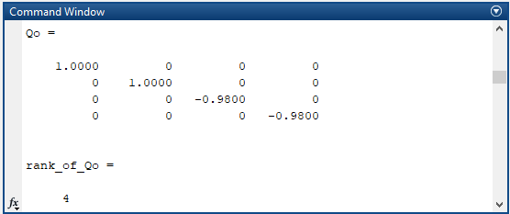

Matlab Result of the inverse of the transformation matrix P and matrix P is given below

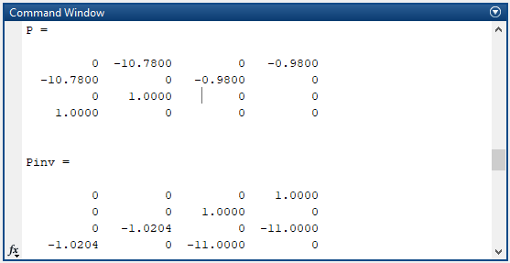

Matlab Result of observable canonical form is given below

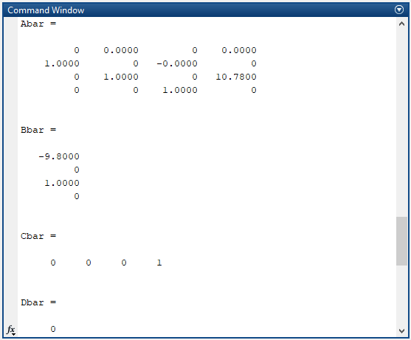

Matlab Result of observable canonical form is given below

$$\left[\begin{aligned}x_{1} \\ x_{2} \\ x_{3} \\ x_{4}\end{aligned}\right]= \left[\begin{matrix}0 & 0 & 0 & 0 \\ 1 & 0 & 0 & 0 \\ 0 & 1 & 0 & 10.78 \\ 0 & 0 & 1 & 0\end{matrix}\right]\left[\begin{aligned}x_{1} \\ x_{2} \\ x_{3} \\ x_{4}\end{aligned}\right]+ \left[\begin{aligned}-9.8 \\ 0 \\ 1 \\ 0\end{aligned}\right]u$$

$$y= \left[0 0 0 1\right] \left[\begin{aligned}x_{1} \\ x_{2} \\ x_{3} \\ x_{4}\end{aligned}\right]$$

# Matlab Code

%Define the Parameters m, M, l, g.

syms s;

m=0.1;

M=1;

l=1;

g=9.8;

%Define the matrix A, B, C, D, I

A=[0 1 0 0; 0 0 (-m*g)/M 0; 0 0 0 1; 0 0 (m+M)*g/(M*l) 0]

B=[0 1/M 0 -1/M ]'

C=[1 0 0 0]

D=0;

I=eye(4)

%Find the observability matrix Q and check its rank

Qo= obsv(A,C)

rank_of_Qo=rank(Qo)

%find the characteristic Equation of system and find matrix W

poly=det(s*I-A)

coeff = sym2poly(poly)

a1=coeff(2)

a2=coeff(3)

a3=coeff(4)

W=[a1 a2 a3 1; a2 a3 1 0; a3 1 0 0; 1 0 0 0]

%find transformation matrix P

P=W*Qo

Pinv=inv(P)

%find the observable canonical form

Abar=P*A*Pinv

Bbar=P*B

Cbar=C*Pinv

Dbar=D

# Question 05

Find the transfer function of the system.

# Solution of Question 05

# Matlab Steps

In Matlab for finding the transfer function of given system we use two different methods.

Method 01

1. From the given state space model we define the matrix A, B, C and D, then we find state space model using matlab command **“sys = ss(A, B, C, D)”**, after that we find transfer function using command **“tf(sys)”.**

Method 2

1. From the given state space model we define the matrix A, B, C and D, Then by using **“ss2tf (A,B,C,D)”** command which get us numerator and denominator of the transfer function. Then to represent the numerator and denominator in terms of transfer function we use **“tf (numerator, denominator)”** command.

# Matlab Result

Matlab Result of Transfer Function is given below.

# 

# Matlab Code

%Question No 5

%Build a state space model of the system and determine the parameters.

close all;

clear all;

clc;

%Define the Parameters m, M, l, g.

m=0.1;

M=1;

l=1;

g=9.8;

%Define the matrix A, B, C, D, I

A=[0 1 0 0; 0 0 (-m*g)/M 0; 0 0 0 1; 0 0 (m+M)*g/(M*l) 0]

B=[0 1/M 0 -1/M ]'

C=[1 0 0 0]

D=0;

I=eye(4)

%Method 01 for finding Transfer function

sys = ss(A, B, C, D)

TransferFun01 = tf(sys)

% Method 02 for finding Transfer function

[num,den] = ss2tf (A,B,C,D);

TransferFun02 = tf(num,den)